Docker Task -2

Task Description:

Create a dockerfile, docker-compose file which when executed must display your basic details in the website.

Create a dockerfile
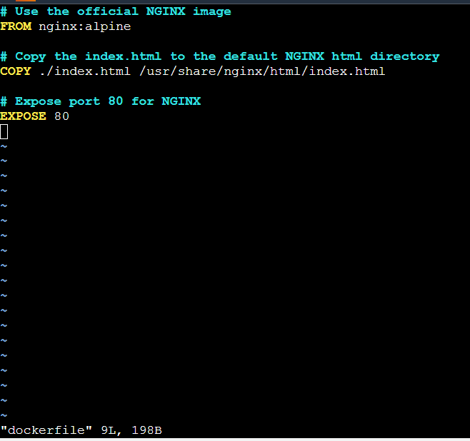

docker-compose file

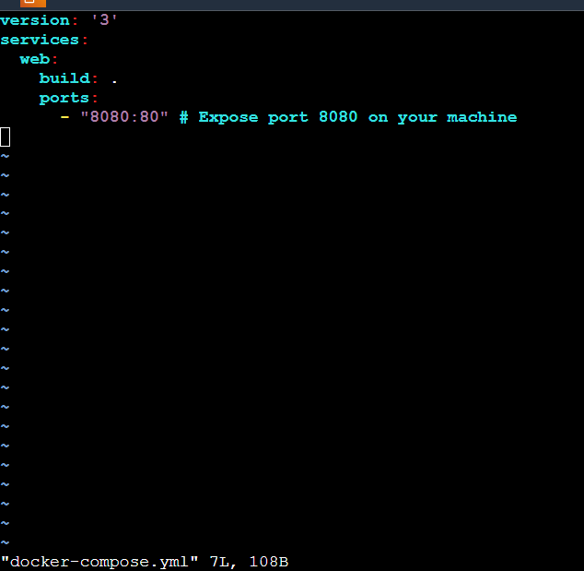

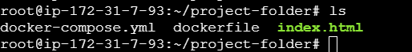

Display your basic details in the website.

